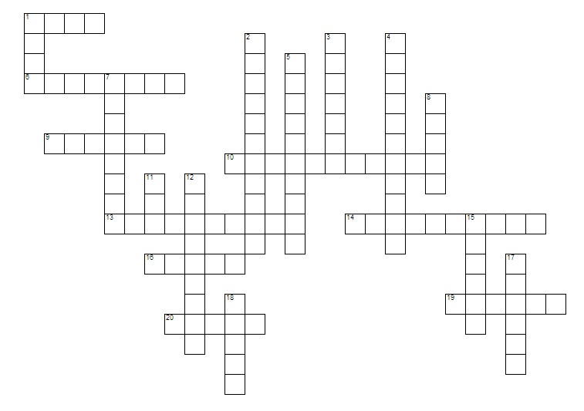
ACROSS
 | 1 | How do you get down after being lifted by fizzy lifting drinks? (4)
 | 6 | On the first day of what month are the children invited to the factory? (8)
 | 9 | How many people crowded around Charlie when he won the ticket? (6)
 | 10 | The main meal in the Bucket Household (7, 4)
 | 13 | Number of squirrels who grabbed Veruca's left leg (6, 4)
 | 14 | What Mr Teavee declares he has had enough of at the end of the book (10)
 | 16 | Vitamin H makes you grow... (5)
 | 19 | The name of Mrs Bucket's father (6)
 | 20 | The surname of the first golden ticket finder (5)

DOWN
 | 1 | The meat in Violet's chewing-gum meal (4)
 | 2 | What is Wonka's special cushions made of? (11)
 | 3 | According to Wonka speaking to Charlie, what is impossible? (7)
 | 4 | a beast that would eat 10 Oompa-Loompas for breakfast (11)
 | 5 | According to Wonka, what does a snozzberry taste exactly like? (10)
 | 7 | The button on the Great Glass Elevator Wonka has been dying to press (2,3,3)
 | 8 | Needed to make whipped cream (5)
 | 11 | The name of Mr Bucket's father (3)
 | 12 | Wonka's Factory is the only one in the world to mix chocolate by... (9)
 | 15 | The colour of Veruca Salt's mink coat (6)
 | 17 | What does Wonka say is made of the curly wooden shavings you find in pencil sharpeners? (6)
 | 18 | Wonka invents square sweets that look... (5)
