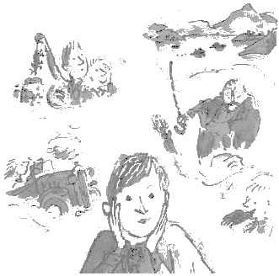

Boy – Tales of Childhood

By Roald Dahl

ASSIGNMENT

Instructions:

- You must complete ONE question from EACH of the three sections
- Sections one and two are worth 15 marks each, section three is worth 10 marks
- This assignment is due ONE WEEK from the end of Week 4 of this unit
- Please include any references or other materials you used in the creation of your work in your assignment folder
- Where possible/practicable, please submit your work in a word-processed format, double spaced
- There is no upper limit on how much you should submit for this assignment, however as a rough guide you should aim to produce 2 - 3 A4 pages each for Sections One and Two, and 1 ½ - 2 A4 pages for Section Three

Section One:

1. Write a memorial article for a major newspaper or magazine about Roald Dahl on the occasion of his death in 1990. You might like to consider creating interviews with friends, family and contemporaries, reflections on his work, etc.

OR

2. Design a travel brochure for Dahl enthusiasts. This is to take them to all the major destinations in Boy, its sequel Going Solo, and any other places you think appropriate – perhaps some of the places (real or fictional) mentioned in his other books. Provide a full list of activities for your travellers to do on their trip.

Section Two:

3. “An autobiography is a book a person writes about his own life and it is usually full of all sorts of boring details.
This is not an autobiography.” (Roald Dahl, Boy, page 7)

Do you agree with the above statement? Why/why not? How does Boy fit the mould of autobiography? In what ways does it differ?

OR

4. “Who can tell where Roald Dahl gets his ideas from? Perhaps some have their roots in the remarkable things that happened to the writer as a boy and as a young man” (Inside cover blurb to Boy)

To what extent is a person defined by their experiences? How is personality and outlook affected by whom we have been? Discuss this with particular reference to Boy, however you may include some references to other texts if you wish.

Section Three:

5. Find at least three articles about corporal punishment. Summarise the viewpoint presented by each of these. What does this tell us about the way corporal punishment is viewed in today’s society? You need not limit yourself to articles on corporal punishment in schools.

OR

6. Pick an issue/idea that interests you that has arisen in your study of/reflection on Boy. Consult with me in order to produce a topic upon which you will complete a research paper.

